Dear Sir or Madam,
Mercator wants to offer its customers more than just ordinary shopping; we want them to have a pleasant experience, explore new products and discover specialties. And it is cuisine that makes us get to know the people, the culture, the history and the way of life of other countries in the most authentic way. This represents true wealth.
As the largest retailer in Slovenia with almost 500 stores, we would like to give you the opportunity to promote the tastes and specialties of your country in 2022. In recent years, Mercator has very successfully introduced to its customers the specialities of Indian, Irish, Southeastern Europe, British, Russian and Italian cuisine. Besides the sale and promotion of food that best represents a certain country, Mercator has also organised tastings and events, and printed special flyers. This way, our customers got to know many products and producers from other countries they would not have normally got to know, and the best-selling products even got a permanent spot on the shelves of our stores. This also opens up new possibilities for products from smaller and lesser known companies representing the food-processing industry of other countries and at the same time makes our selection more varied and interesting, and our customers even happier.
Of course, investment in this kind of promotion, as well as the scope of engagement by the participating parties and the size of the project can vary. Each cooperation of this kind, however, is entered into by Mercator with the utmost level of professionalism, because we are determined to provide both our partners and customers with excellence.
If you are interested in this kind of cooperation for the promotion of suppliers from your country, we are always available for a meeting to introduce the possibilities Mercator offers in this area.
We have created the table below and we would like to ask you to fill it in, so we can incorporate the project in the calendar year 2022.

PROPOSED DATE OF COOPERATION | PROJECT SCOPE (NUMBER OF UNITS) | YOUR ACTIVITIES, AS FORESEEN ON THE PROPOSED DATE OF COOPERATION WITH US
Your proposition | Your proposition | Your proposition

Please let us know about your decision by 31 January 2022.
Kind regards,
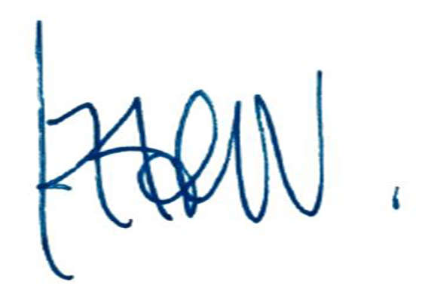
Iztok Verdnik,
Senior Vice President, Corporate Communications, Mercator

